STEP 1: Create a Custom VPC
- Log in to AWS Console and go to VPC Dashboard.
- In the left menu, select Your VPCs > Create VPC: 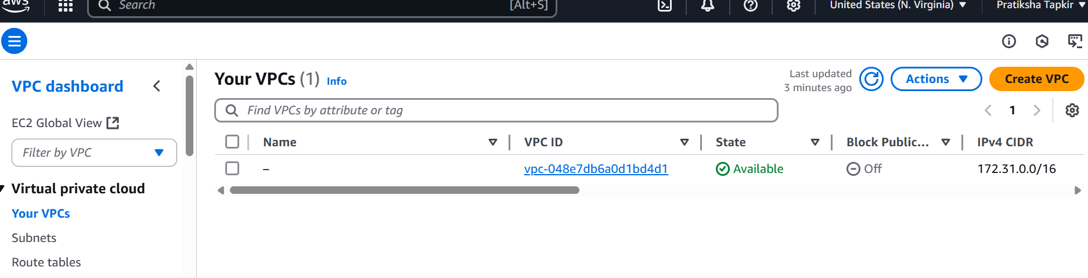
  - Name tag: MyCustomVPC
  - IPv4 CIDR block: 10.0.0.0/16
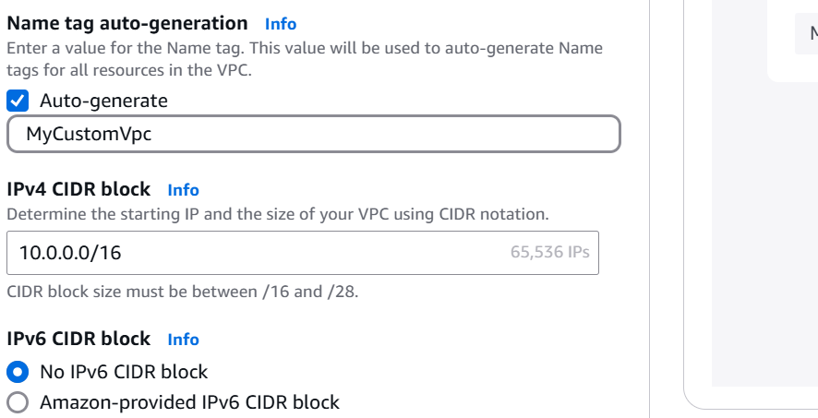
  - Click Create VPC
- Create two subnets:
  - Go to Subnets > Create subnet
    - VPC ID: Select MyCustomVPC
    - Subnet name: PublicSubnet
    - Availability Zone: Select one (e.g., us-east-1a)
    - IPv4 CIDR block: 10.0.1.0/24
  - Repeat for PrivateSubnet: use 10.0.2.0/24

- Create and attach Internet Gateway (for public subnet):
  - Go to Internet Gateways > Create Internet Gateway
    - Name: MyIGW
  - Attach it to MyCustomVPC
- Route table configuration:
  - Go to Route Tables > Create route table
    - Name: PublicRouteTable, VPC: MyCustomVPC
  - Add a route:
    - Destination: 0.0.0.0/0
    - Target: MyIGW
  - Associate PublicRouteTable with PublicSubnet
  - Do NOT associate PrivateSubnet with it (it will use default local routing)
STEP 1: Create Custom VPC Using “VPC and more” Wizard
- Go to the AWS Management Console.
- Navigate to VPC > Your VPCs > Launch VPC Wizard or “VPC and more” (found in the VPC Dashboard).
- Select the option:
  - VPC with Public and Private Subnets
- Fill in details:
  - Name tag: MyCustomVPC
  - IPv4 CIDR block: 10.0.0.0/16
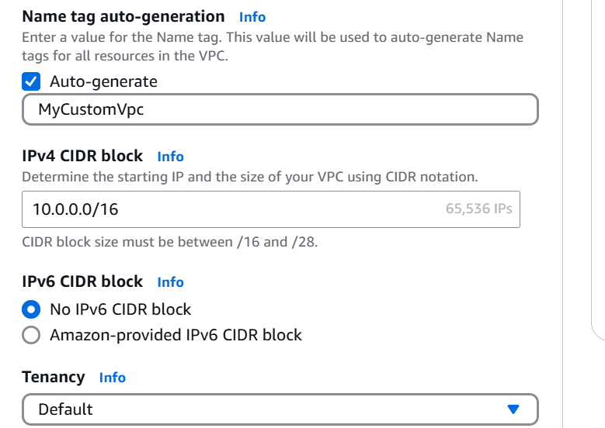
  - Public subnet CIDR: 10.0.1.0/24
  - Private subnet CIDR: 10.0.2.0/24
  - Availability Zone: Choose one (e.g., us-east-1a)
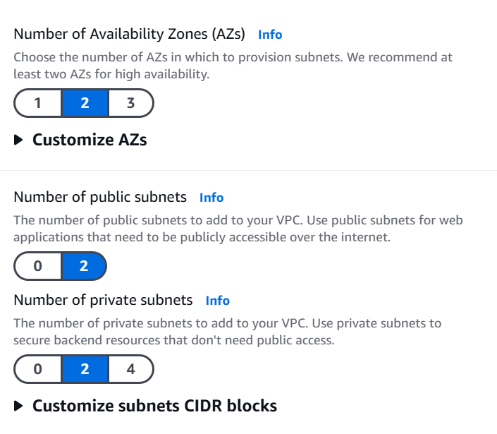
  - Enable NAT Gateway: ✅ Yes (Required for RDS outbound internet access)
    - It will ask to create an Elastic IP
  - DNS hostnames and DNS resolution: Leave default (enabled)
- Click Create VPC
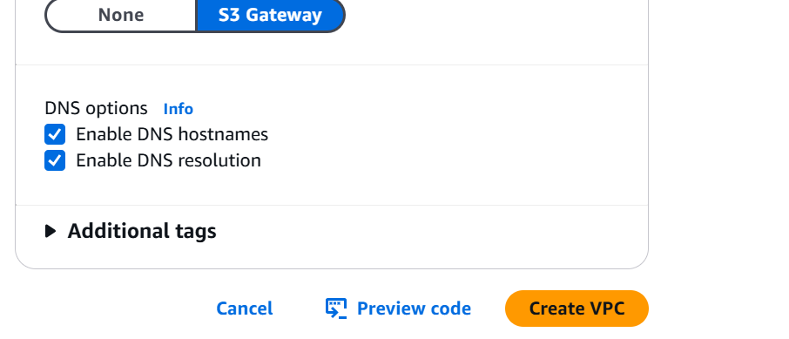
✅ This will automatically create:
- A VPC
- Public + Private subnets
- Route tables
- Internet Gateway
- NAT Gateway
- Subnet associations
- Security groups (basic)

STEP 2: Create RDS (SQL Server) in the Custom VPC
- Go to RDS > Databases > Create database
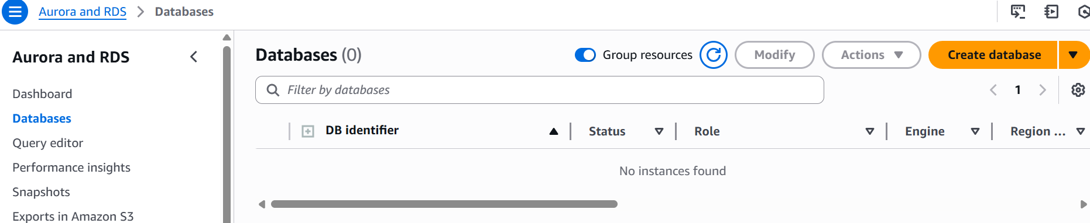
- Choose:
  - Standard Create
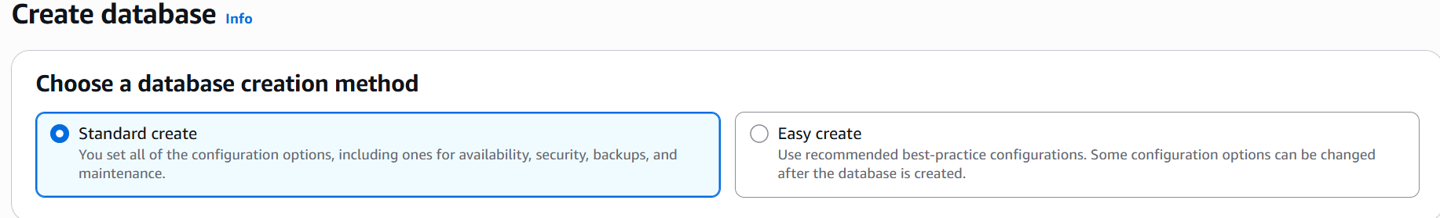
  - Engine: Microsoft SQL Server
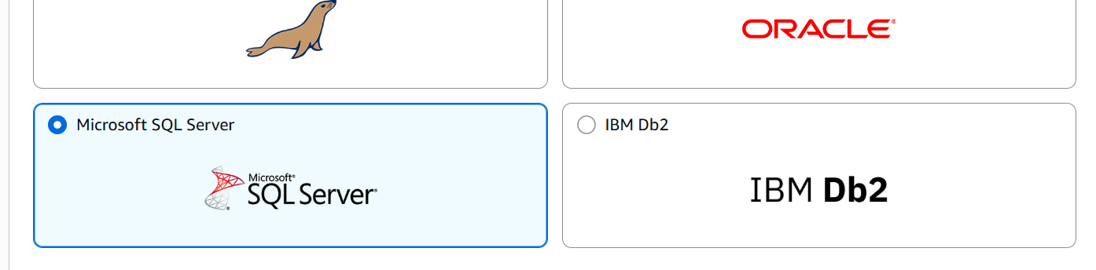
  - Edition: Express or Standard (your choice)
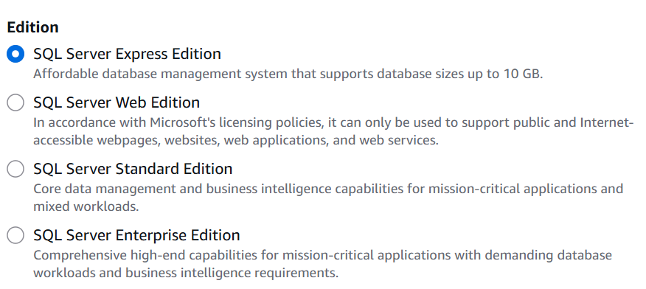
- Settings:
  - DB instance identifier: my-sql-db
  - Master username: admin
  - Password: Choose a strong one (e.g., MySecurePass123!)
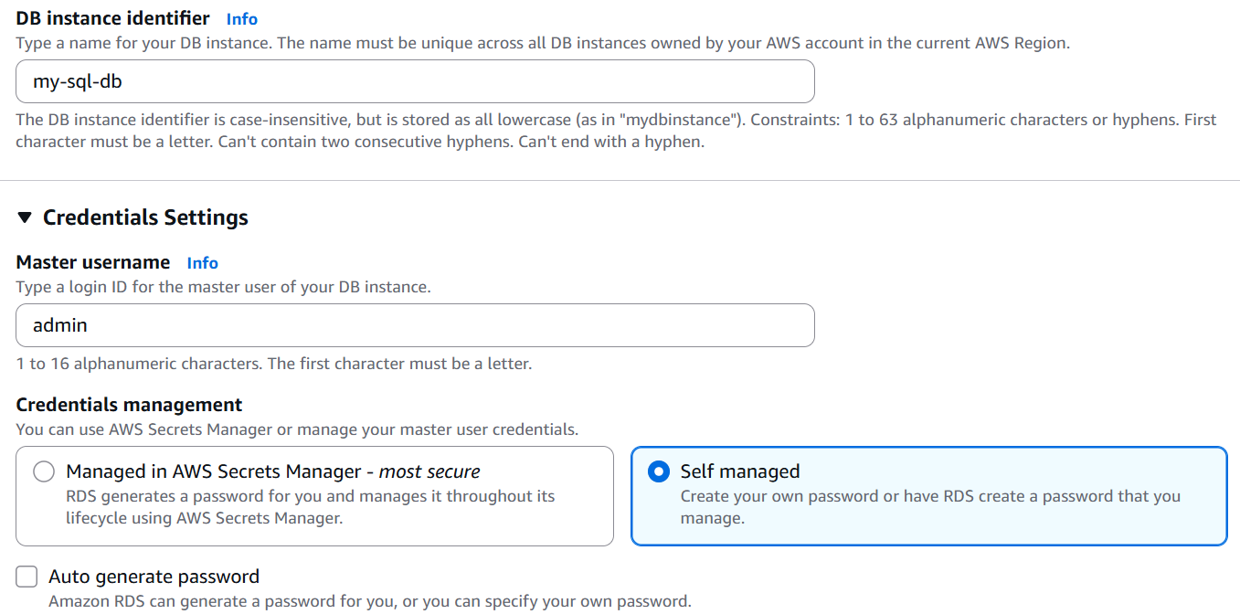
- DB instance class: Use db.t3.micro (Free Tier) or larger
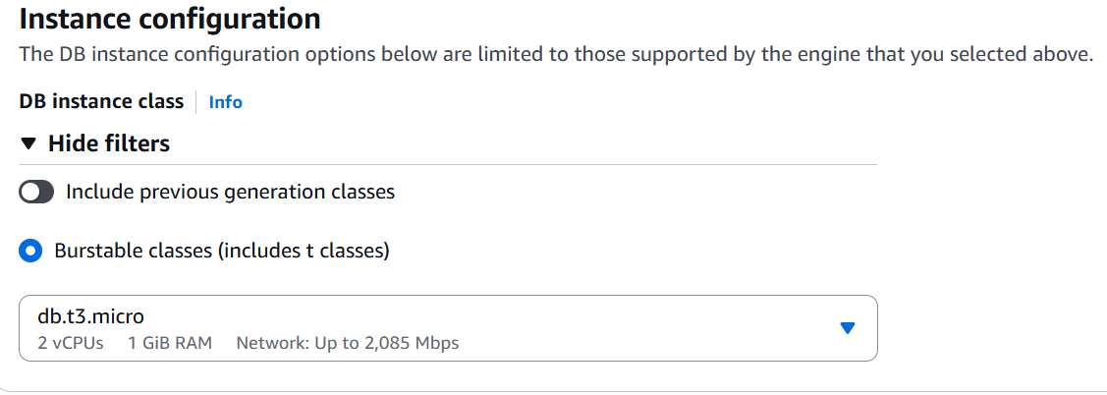
- Connectivity settings:
  - Virtual Private Cloud (VPC): Select MyCustomVPC
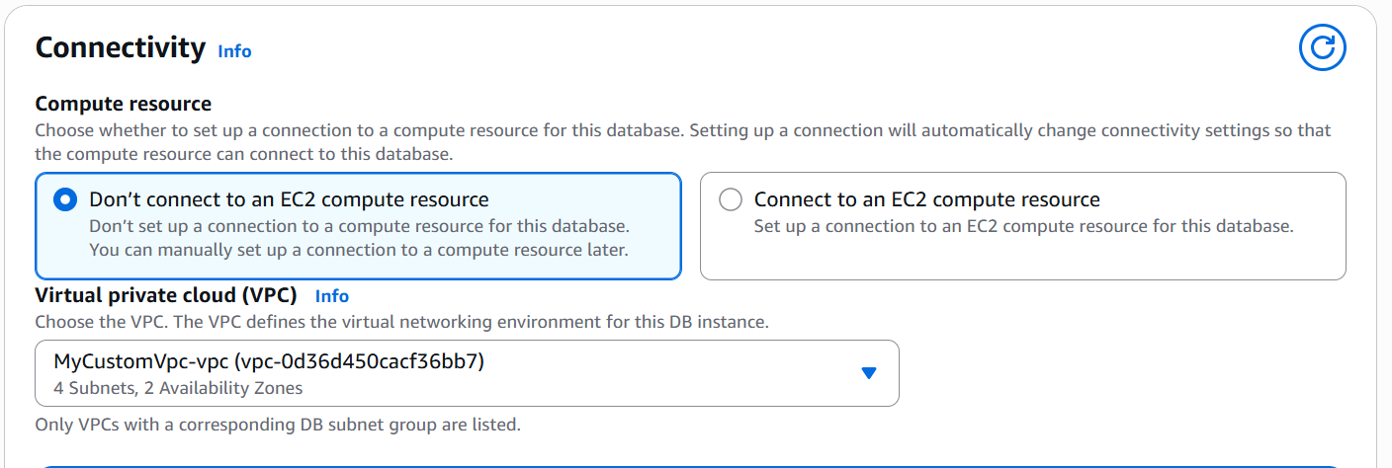
  - Subnet group: It will show a default group with private subnets (or create new)
  - Public access: Select No
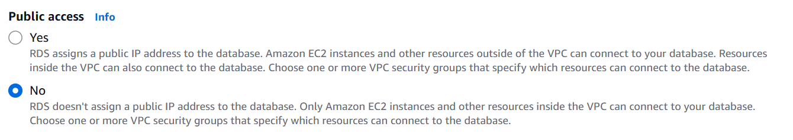
  - Availability Zone: leave default or match previous
  - VPC security group: Create new or use existing, ensure:
    - Inbound Rule:
      - Port: 1433
      - Source: Public subnet’s IP or Jump server security group (we'll use this later)
- Click Create Database

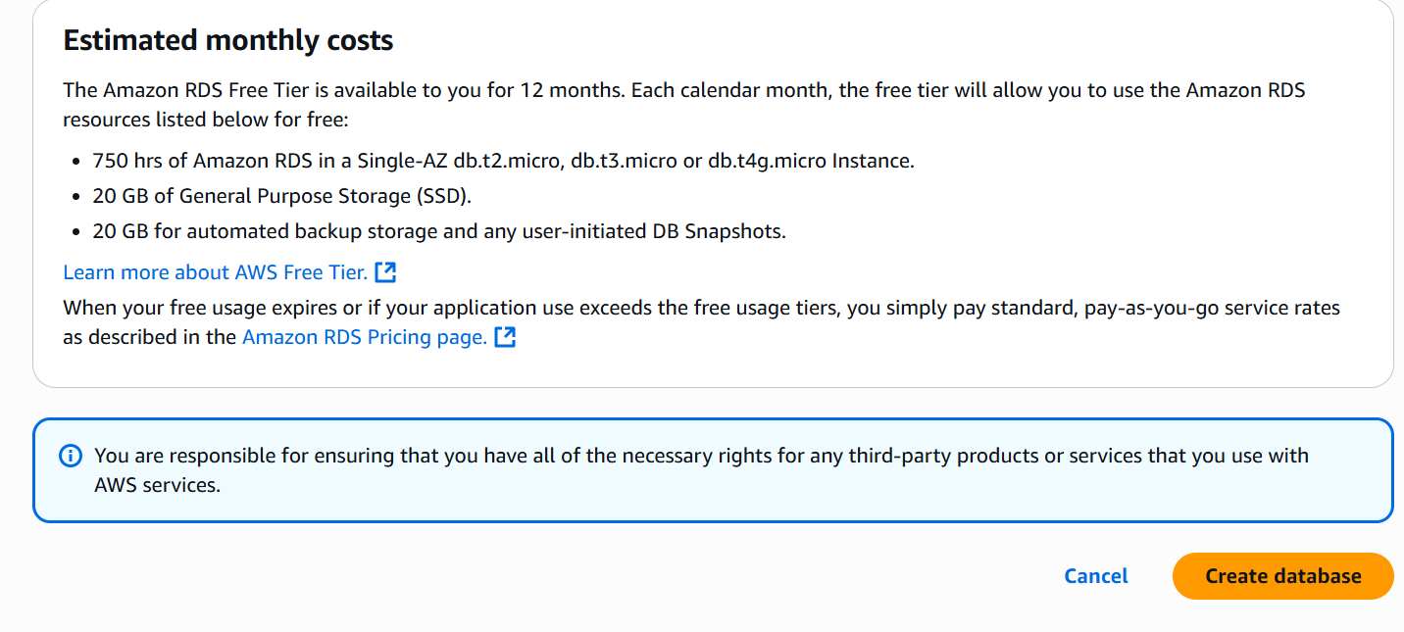
STEP 3: Launch a Jump Server (Bastion Host) in Public Subnet
- Go to EC2 > Instances > Launch Instance
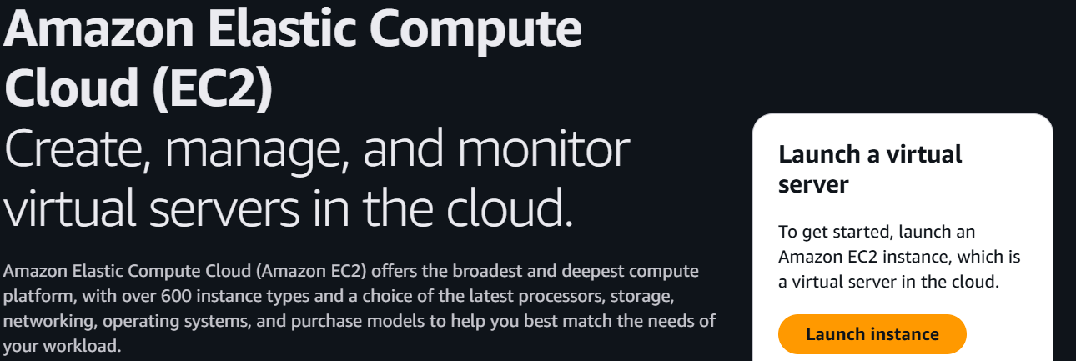
- Configure:
  - Name: JumpServer
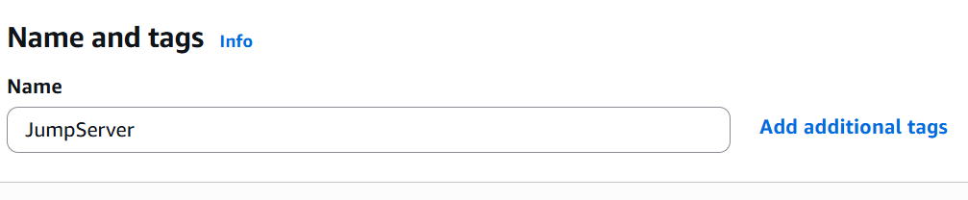
  - AMI: Use Windows Server (for SSMS), or Amazon Linux if you prefer CLI
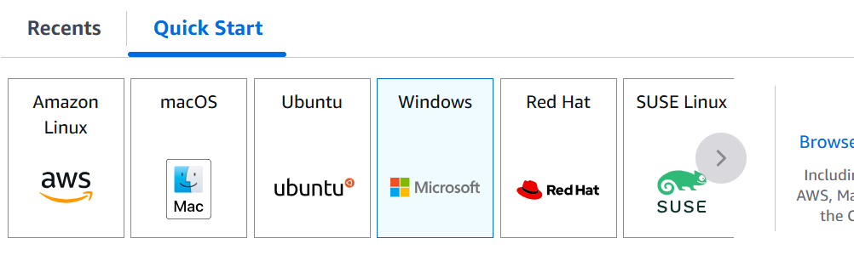
  - Instance type: t2.micro (Free Tier)
  - Key Pair: Choose existing or create new
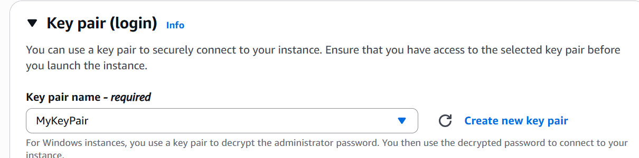
  - Network: MyCustomVPC
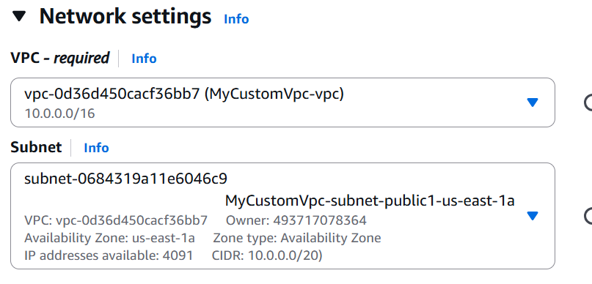
  - Subnet: PublicSubnet
  - Auto-assign Public IP: Enabled
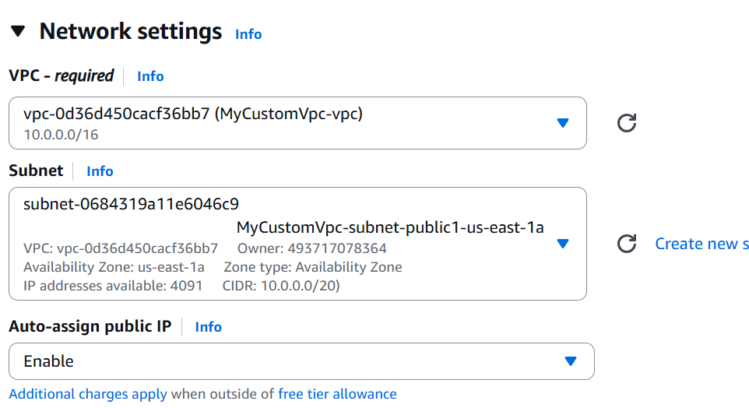
- Security Group:
  - For Windows: allow RDP (port 3389) from your IP
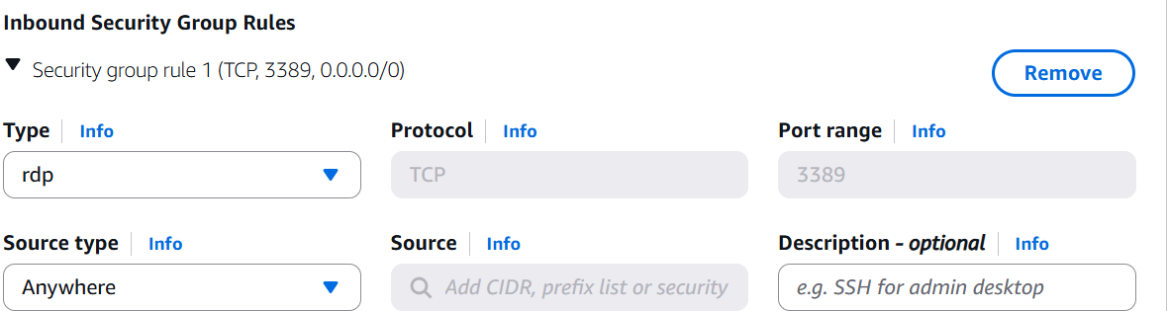
  - For Linux: allow SSH (port 22)
- Launch the instance
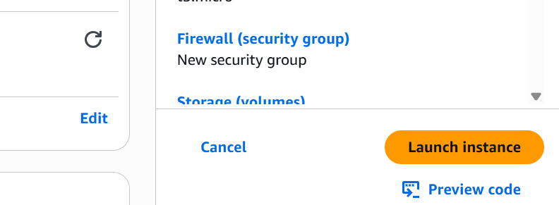

STEP 4: Modify RDS Security Group (If Needed)
- Go to EC2 > Security Groups.
- Find the security group attached to RDS.
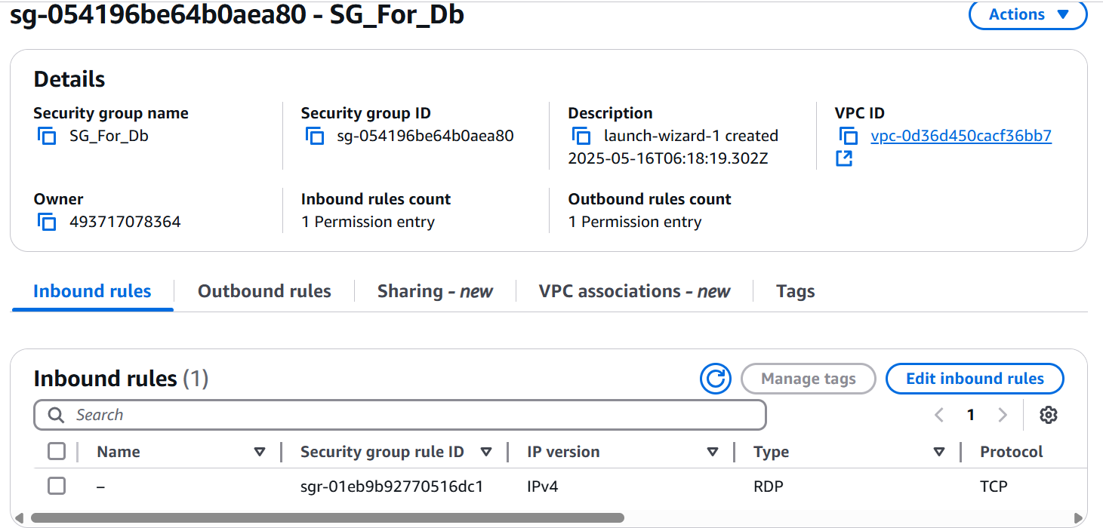
- Add an inbound rule:
  - Type: MS SQL
  - Port: 1433
  - Source: The security group of the Jump Server, or its private IP
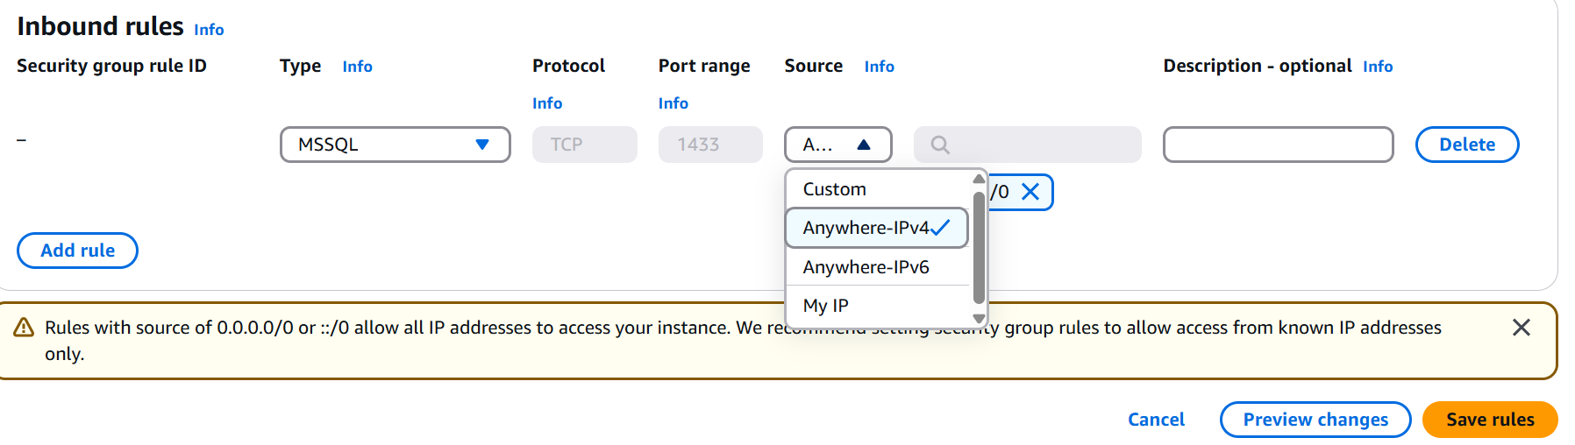
STEP 5: Connect to Jump Server and Then to RDS
If You Used a Windows Jump Server:
- RDP into the instance using its public IP and key pair.
- Open Internet Explorer, download SSMS (SQL Server Management Studio).
  - SSMS Download
- Open SSMS and connect using:
  - Server name: <RDS endpoint> (found in RDS Console)
  - Authentication: SQL Server Authentication
  - Username: admin
  - Password: Your password
